

P

r

o

j

e

c

t

R

e

p

o

r

t

1

I

N

T

R

O

D

U

C

T

I

O

1

.

1

O

v

e

r

v

i

e

w

**Travel Trax Tours** is a travel company that offers a variety of tours and travel packages to destinations all over the world. They specialize in small group tours, but also offer private tours and custom-designed itineraries. Travel Trax Tours is known for their high-quality tours, experienced tour guides, and commitment to customer satisfaction.

* 1. Purpose
* To provide their customers with a variety of tour options to choose from, so that they can find the perfect tour for their interests and budget.
* To offer high-quality tours with experienced tour guides who are passionate about their work.
* To be committed to customer satisfaction and to providing their customers with the best possible travel experience.
* To help their customers learn about different cultures, experience new things, and create lasting memories.

2.1 Empathy Map

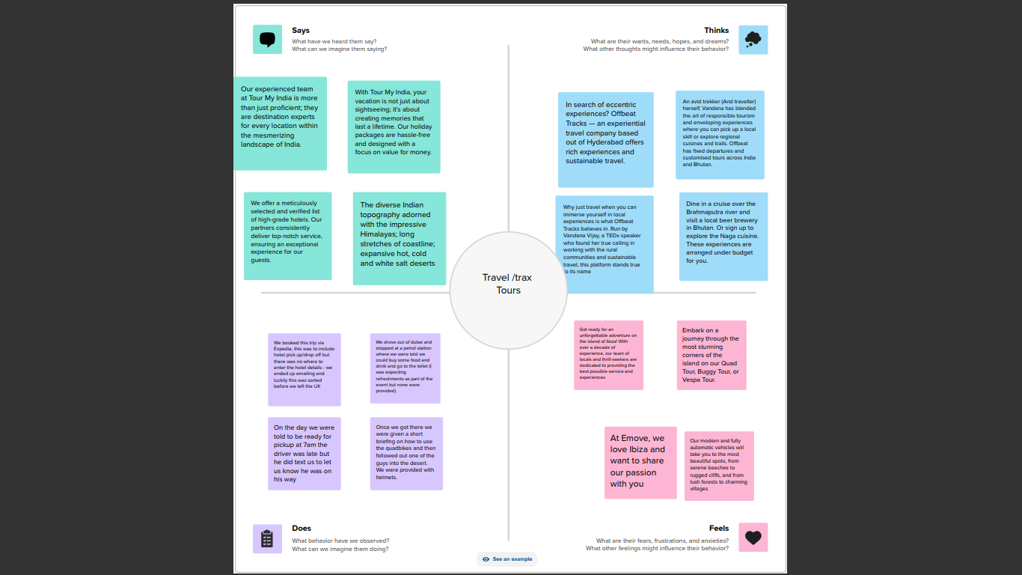



2.2 Ideation & Brain Storming Map





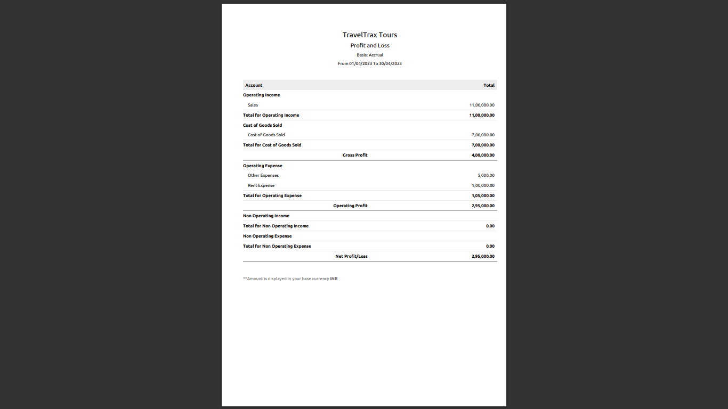

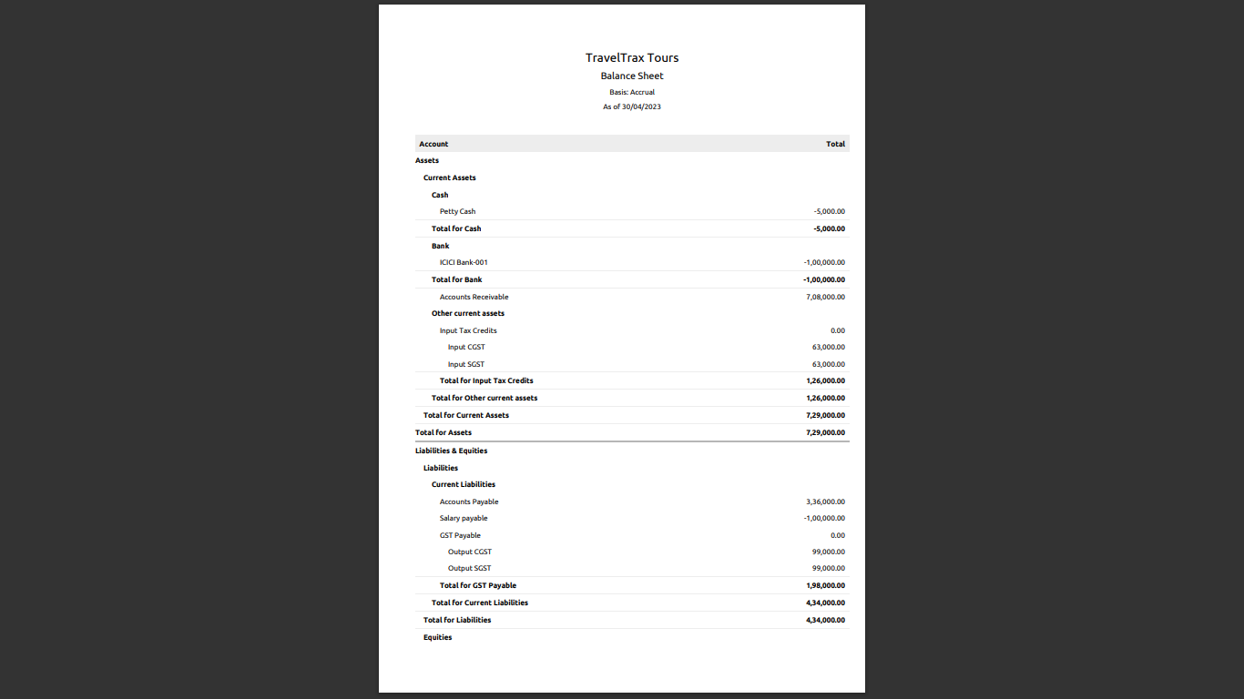

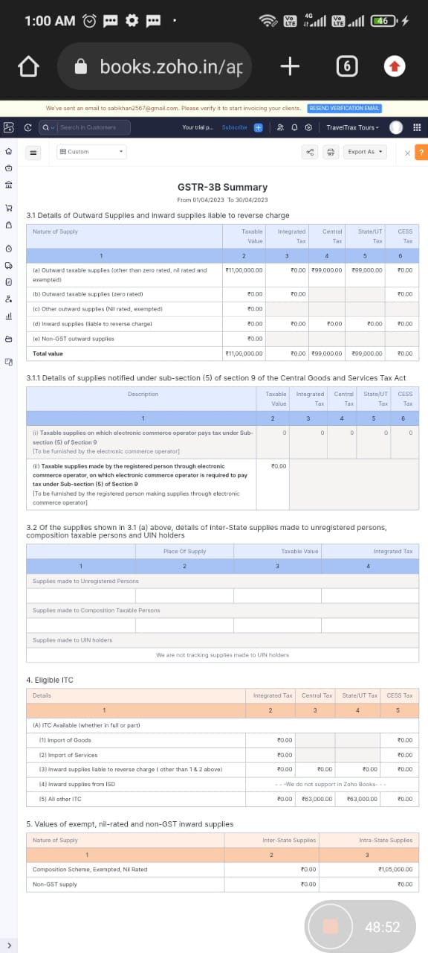



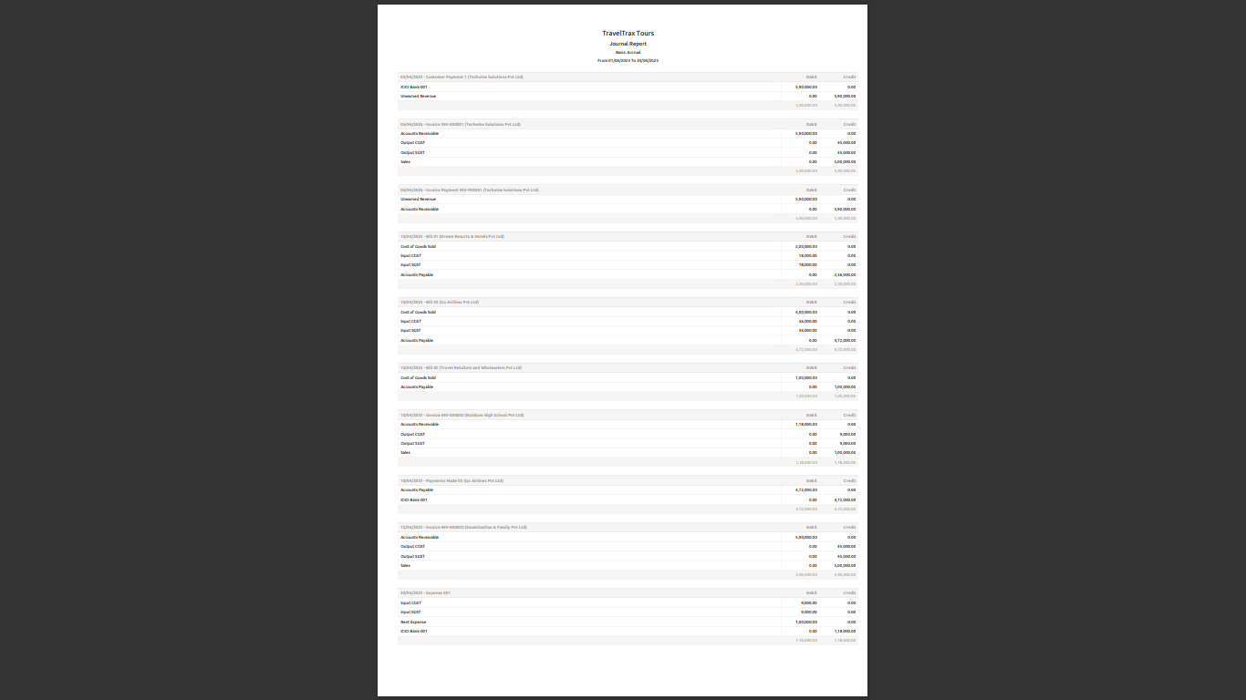

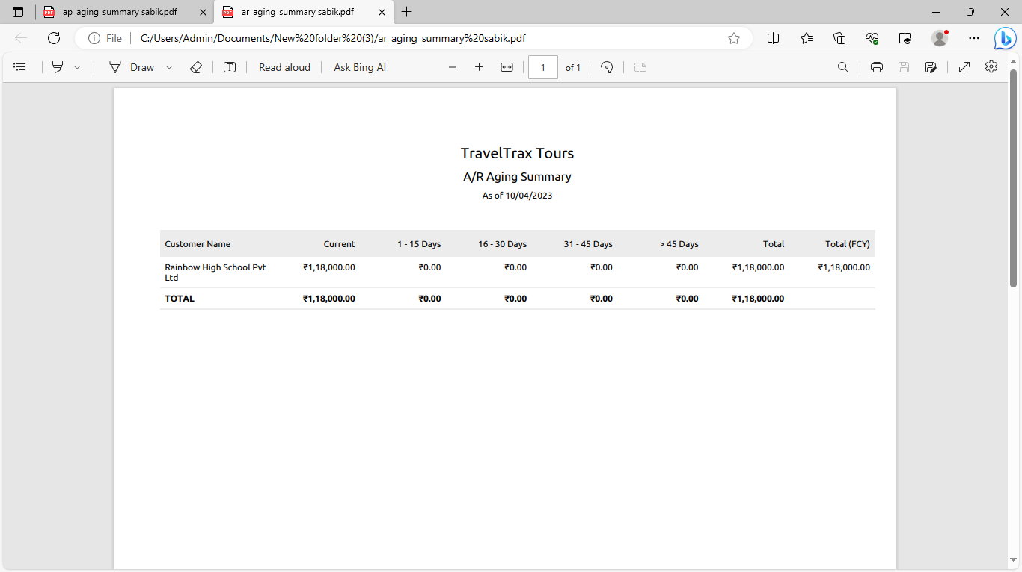

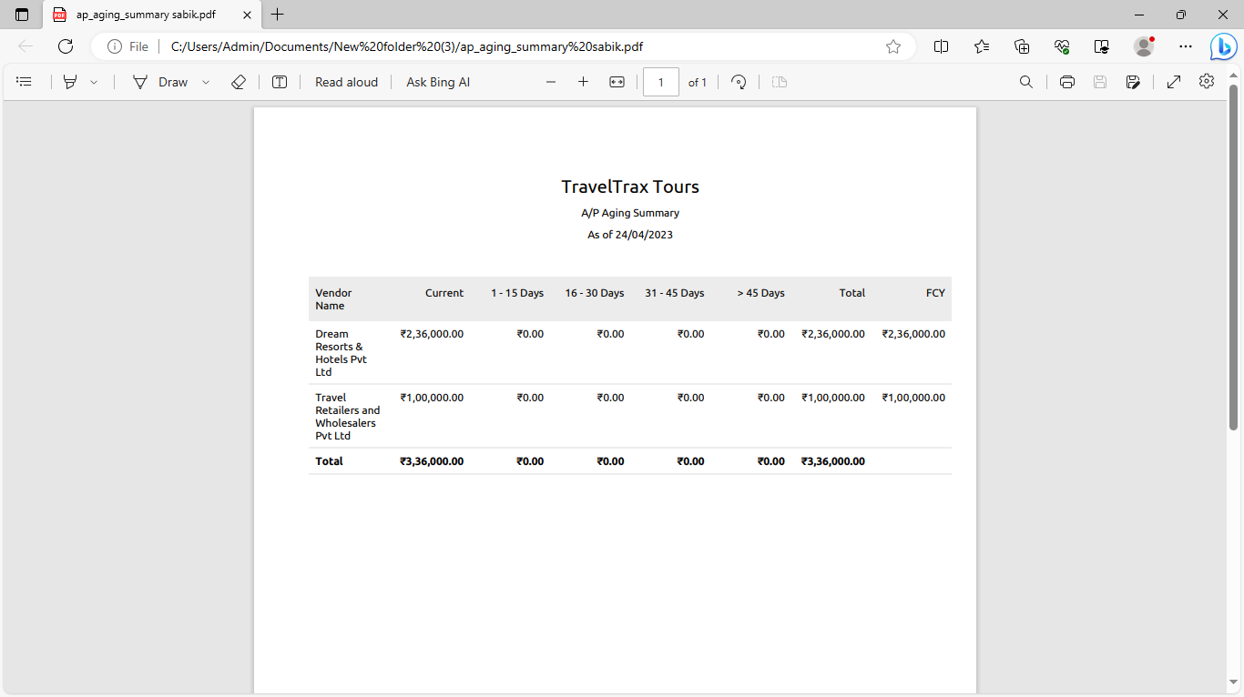

1.Advantages



4

A

D

V

A

N

T

A

G

E

S

&

D

I

S

A

D

V

A

N

T

A

G

E

S

* High-quality tours: Travel Trax Tours is known for their high-quality tours. They use experienced tour guides, comfortable transportation, and well-planned itineraries.
* Variety of tours: Travel Trax Tours offers a variety of tours to destinations all over the world, so you can find the perfect tour for your interests and budget.
* Small group tours: Travel Trax Tours specializes in small group tours, which allows for a more personal and engaging experience.
* Custom-designed itineraries: Travel Trax Tours can also create custom-designed itineraries to meet your specific needs and interests.
* Commitment to customer satisfaction: Travel Trax Tours is committed to providing their customers with the best possible travel experience. They are responsive to customer feedback and are always willing to go the extra mile to make sure their customers are happy.

2.Disadvantages

* Limited tour availability: Because Travel Trax Tours specializes in small group tours, their tours can book up quickly, especially during peak travel season. If you are interested in booking a tour with Travel Trax Tours, it is important to book well in advance.
* Higher prices: Travel Trax Tours' tours are typically more expensive than tours offered by larger travel companies. This is because Travel Trax Tours offers smaller group sizes, more experienced tour guides, and more personalized itineraries.
* Less flexibility: Travel Trax Tours' tours have fixed itineraries, which means that you may not have as much flexibility as you would with a custom-designed tour. If you are looking for a more flexible travel experience, you may want to consider booking a custom tour with a different company.
* Limited tour destinations: Travel Trax Tours does not offer tours to all destinations. If you are interested in visiting a destination that Travel Trax Tours does not offer tours to, you will need to book a tour with a different company.
* Negative customer reviews: While Travel Trax Tours has a mostly positive reputation, there have been some negative customer reviews. These reviews typically complain about poor customer service, subpar tour guides, and unexpected changes to itineraries.

# 

* Vacations: Travel Trax Tours offers a variety of tours to popular vacation destinations all over the world. This makes them a good option for travelers who are looking for a hassle-free vacation experience.
* Adventure travel: Travel Trax Tours also offers a variety of adventure tours, such as hiking tours, camping tours, and safari tours. This makes them a good option for travelers who are looking for a more adventurous travel experience.

Travel Trax Tours is a well-established travel company with a good reputation. They offer a variety of tours to destinations all over the world, and they are known for their high-quality tours, experienced tour guides, and commitment to customer satisfaction.



7

F

U

T

U

R

E

S

C

O

P

E

Travel Trax Tours has a bright future ahead of it. The travel industry is expected to continue to grow in the coming years, and Travel Trax Tours is well-positioned to capitalize on this growth.

Here are some specific ways that Travel Trax Tours can expand its business in the future:

* Expand to new destinations: Travel Trax Tours can expand its business by offering tours to new destinations. This would allow them to reach a wider range of customers and offer a more diverse product portfolio.
* Offer more specialized tours: Travel Trax Tours can also expand its business by offering more specialized tours. For example, they could offer tours focused on specific interests, such as food, wine, or history.
* Partner with other travel companies: Travel Trax Tours can also expand its business by partnering with other travel companies. This would allow them to offer a wider range of products and services to their customers.
* Partner with other travel companies: Travel Trax Tours can also expand its business by partnering with other travel companies. This would allow them to offer a wider range of products and services to their customers.
* Travel Trax Tours can also take steps to become more sustainable and environmentally friendly. For example, they could offset the carbon emissions from their tours and use sustainable transportation options. This would make them more appealing to customers who are concerned about the environment.
* Overall, Travel Trax Tours has a lot of potential for growth in the future. By expanding its business, investing in technology, and becoming more sustainable, Travel Trax Tours can continue to provide its customers with high-quality travel experiences.

# 

* Visas and passports: Requirements for obtaining a visa or passport for the country or countries you will be visiting.
* Currency: Information on the currency of the country or countries you will be visiting, including exchange rates and where to exchange money
* Transportation: Information on how to get around the country or countries you will be visiting, including public transportation, taxis, and rental cars.
* Accommodation: Information on different types of accommodation available in the country or countries you will be visiting, including hotels, hostels, and guesthouses.
* Food and drink: Information on different types of food and drink available in the country or countries you will be visiting, including restaurants, cafes, and bars.
* .